Technical Career Education Private Limited
5th floor, Sahyadri Campus, Adyar, Mangalore 575007


Full Stack Development Skill Lab Course
PROJECT REPORT
2024 - 25

Project Title: ‘MOVIE HUB’
Submitted by:
Adarsha Krishna k 4SF25CS400
Chiranth R 4SF25CS402

Institution:

Sahyadri College of Engineering and Management
Adyar Mangalore 575007

CONTENTS

Project Overview

- Introduction

- Problem Statement

3. Solution
3.1 System requirements for the project.
3.2 Flowchart of the project.
3.3 Frontend
3.4 Backend

4. Conclusion/Outcome:

5. Reference List
Project Overview

Problem Statement | developing a movie web application using Node.js with HTML and CSS.
Class/ Section | 3 A
Team Name | VICTUS
Team Members | Name | USN | Github Link
Team Members | Adarsha Krishna k | 4S25CS400 | https://github.com/chirabyte/milestone-2.git
Team Members | Chiranth R | 4S25CS402 | https://github.com/chirabyte/milestone-2.git

1. INTRODUCTION
In the modern digital era, online streaming platforms and movie databases have become an essential part of entertainment. Users expect fast access to movie information such as titles, genres, ratings, and recommendations. Web applications that provide these features must be responsive, user-friendly, and dynamic.
This project focuses on the design and development of a Movie Application using React.js that allows users to browse, search, and explore movies using real-time data fetched from The Movie Database (TMDB) API. The application provides features such as category-wise movie listings, live search suggestions, infinite scrolling, and a favorites system using local storage.
The goal of this project is to demonstrate practical knowledge of React, API integration, component-based architecture, and modern UI design principles.

2. Problem Statement
Users often face difficulty in accessing movie information due to complex interfaces and scattered sources. There is a need for a simple and efficient web application that allows users to browse and view movie details in a centralized manner. This project addresses the problem by developing a movie web application using Node.js with
HTML and CSS.

2. OBJECTIVES OF THE PROJECT
The main objectives of this project are:
- To design a responsive and interactive movie browsing application.
- To integrate a third-party API (TMDB) for real-time movie data.
- To implement category-based movie listings.
- To provide a search feature with movie name suggestions.
- To implement infinite scrolling for smooth user experience.
- To allow users to save favorite movies using localStorage.
- To apply modern UI/UX design with dark and light mode support.

3. TECHNOLOGY STACK USED

3.1 Frontend Technologies
- HTML5 – Structure of the web pages
- CSS3 – Styling, animations, and responsive design
- JavaScript (ES6) – Application logic
- React.js – Component-based frontend framework
3.2 API

• TMDB (The Movie Database) API
o Provides movie details, posters, genres, ratings, and search functionality.

3.3 Tools
- VS Code – Code editor
- Browser (Chrome) – Testing and debugging
- Git (optional) – Version control

4. SYSTEM ARCHITECTURE
The application follows a client-side architecture using React.
Architecture Flow:
- User interacts with the UI (search, scroll, favorites).
- React components handle user actions.
- Axios sends requests to TMDB API.
- TMDB returns movie data in JSON format.
- React updates the UI dynamically.
- Favorites are stored and retrieved from local Storage.

5. FEATURES OF THE APPLICATION

5.1 Home Page
- Displays all movie categories directly without buttons.
- Categories include: o Trending Movies o Indian Movies o Malayalam o Hindi o Tamil o Telugu o Kannada o Horror o Action o Romance o Family o Fantasy

5.2 Search with Auto-Suggestions
- Search bar at the top of the home page.
- As the user types, movie name suggestions appear automatically.
- Clicking a suggestion performs a search instantly.
- Uses TMDB search endpoint.

5.3 Infinite Scrolling
- Movies load dynamically as the user scrolls down.
- Improves performance and user experience.
- Prevents loading all data at once.

5.4 Movie Details Page
- Displays: o Movie poster o Title o Overview (description)
o Genres o Rating o Runtime and Cast
- Option to Add / Remove from Favorites.

5.5 Favorites Page
- Displays all saved favorite movies.
- Uses browser localStorage.
- Favorites persist even after page reload.

5.6 Dark and Light Mode
- Users can toggle between dark and light themes.
- Theme preference is stored locally.

6. API DETAILS
6.1 TMDB API Endpoints Used

Feature Endpoint
Trending Movies /trending/movie/week
Search Movies /search/movie
Discover by Language /discover/movie
Discover by Genre /discover/movie
Movie Details /movie/{id}
Movie Credits /movie/{id}/credits

7. DATA STORAGE

7.1 Local Storage
The application uses localStorage to store:
- Favorite movies
- Theme preference (dark/light)
This allows data persistence without using a backend server.

8. USER INTERFACE DESIGN
- Clean and modern UI.
- Responsive layout for mobile, tablet, and desktop.
- Smooth animations and hover effects.
- Clear typography and readable card layout.

9. ADVANTAGES OF THE SYSTEM
- Real-time movie data.
- No backend required.
- Fast and responsive UI.
- Easy to use and navigate.
- Scalable and modular React components.

10. LIMITATIONS
- Depends on third-party API availability.
- Limited to data provided by TMDB.
- No user authentication system.
- No backend database.

11. FUTURE ENHANCEMENTS
- User login and profile system.
- Trailer playback inside the app.
- User reviews and ratings.
- Recommendation system.
- Backend integration with database.
- Deployment on cloud platforms (Netlify/Vercel).

12. CONCLUSION
The Movie Application successfully demonstrates the use of React.js and TMDB API to build a modern, responsive, and feature-rich web application. The project highlights important frontend concepts such as component-based development, API integration, state management, and local storage usage.
This application serves as a strong foundation for advanced projects and real-world web development scenarios.

13. REFERENCES
- TMDB API Documentation
- React Official Documentation
- MDN Web Docs (HTML, CSS, JavaScript)

Flow Chart

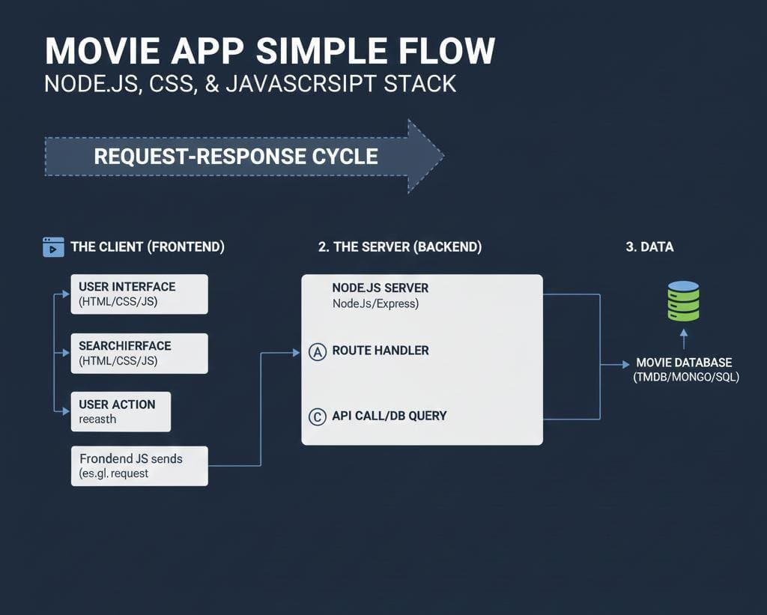

Screenshots

